**Placental Atlas Quantifying Notes**

What are macros??

* Macros are small scripts that automates a series of ImageJ commands. There will be prompts associated with the macro (for example: “Choose mCherry window for threshold”), where the user (you!) needs to execute the command ***before*** hitting ‘OK’ in the window.
* If the macro commands get messed up, close all windows and start over!

**NK Cells** 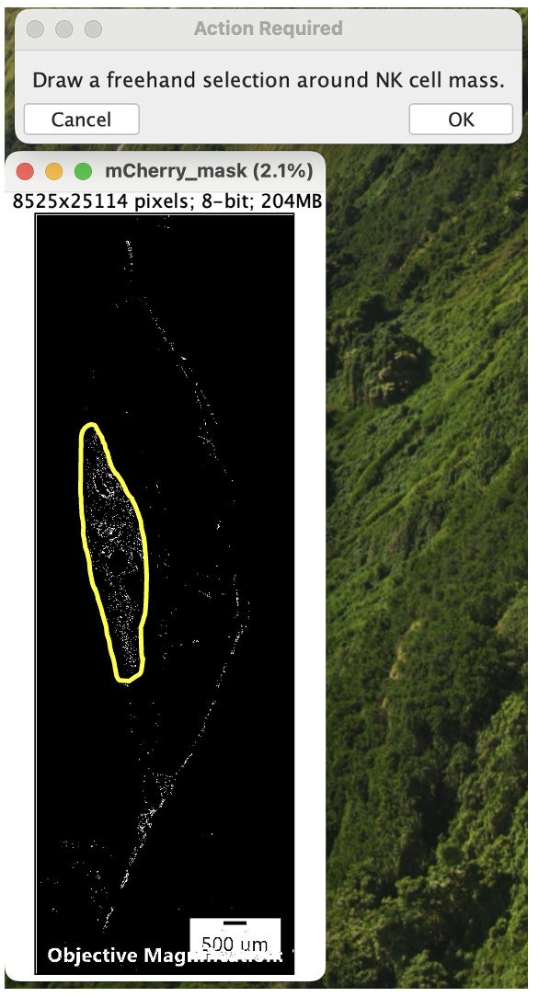

1. Download NK_macro.ijm
2. Load macro into FIJI
   * Plugins > Macros > Install
3. Run macro and follow directions using merged image
   * Plugins > Macros > NK_macro
   * Click ‘OK’ and choose image
4. Record

* Number of NK cells from the “Count” column in the Summary window
* Average size of NK cells from the “Average Size” column in the Summary window

1. Close all windows and proceed to the next quantification step (outlined below).

Troubleshooting:

* + Low number of NK cells: The thresholding is not working, use the [Placental Atlas Quantification – Manual](https://docs.google.com/document/d/1qrNTMrRyqvEbXmIbQEqflC5_J22b_t26GOZHIfxlRb4/edit?usp=drive_link) protocol instead of this Macro protocol for this image.
  + NK cell mass is highlighted
  + Freehand selection is used to avoid points on labyrinth edge of placenta

**Trophoblast Cells**

1. Download Troph_macro.ijm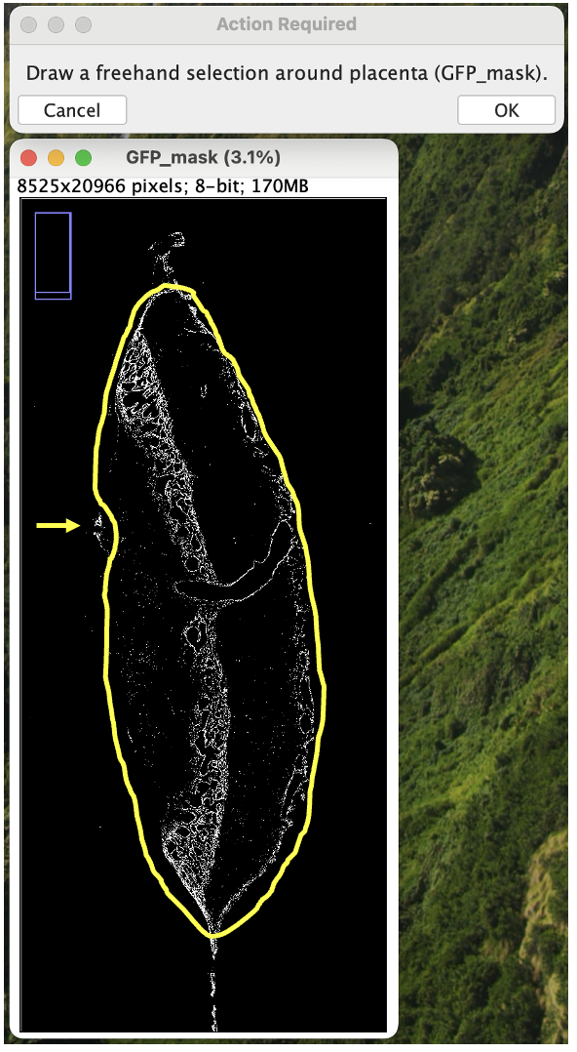
2. Load macro into FIJI
   * Plugins > Macros > Install
3. Run macro and follow directions using merged image
   * Plugins > Macros > Troph_macro
   * Click ‘OK’ and choose image
4. Record-

* Number of trophoblast cells from the “Count” column in the Summary window

1. Close all windows and proceed to next quantification step (outlined below).

Troubleshooting:

* + Freehand selection is used to avoid points around placenta and to avoid stained tissue pieces (rather than cells) – highlighted by arrow

**Placental Measurements**

1. Download Color_macro.ijm
2. Load macro into FIJI
   * Plugins > Macros > Install
3. Run macro and follow directions using merged image
   * Plugins > Macros > Color_macro
   * Click ‘OK’ and choose image
4. Check for NK in other zones

* NK in the junctional zone?
* NK in the labyrinth zone?

1. Measure areas and depths using freehand tool or straight line tool
   * Move around image using scrolling tool (or press space bar and drag)
   * Zoom in using Command (⌘) +
   * Zoom out using Command (⌘) -
   * Freehand/Straight selection > Draw on image
   * Analyze > Measure (or Command (⌘) m)

* Decidual area NK cells (freehand)
* Decidual depth - Left (straight)
* Decidual depth - Center (straight)
* Decidual depth - Right (straight)
* Junctional zone area (freehand)
* Labyrinth zone area (freehand)

*if area numbers are too big, see how to change the scale under “Fiji Cheat sheet”

**Placental zones and measurements:**

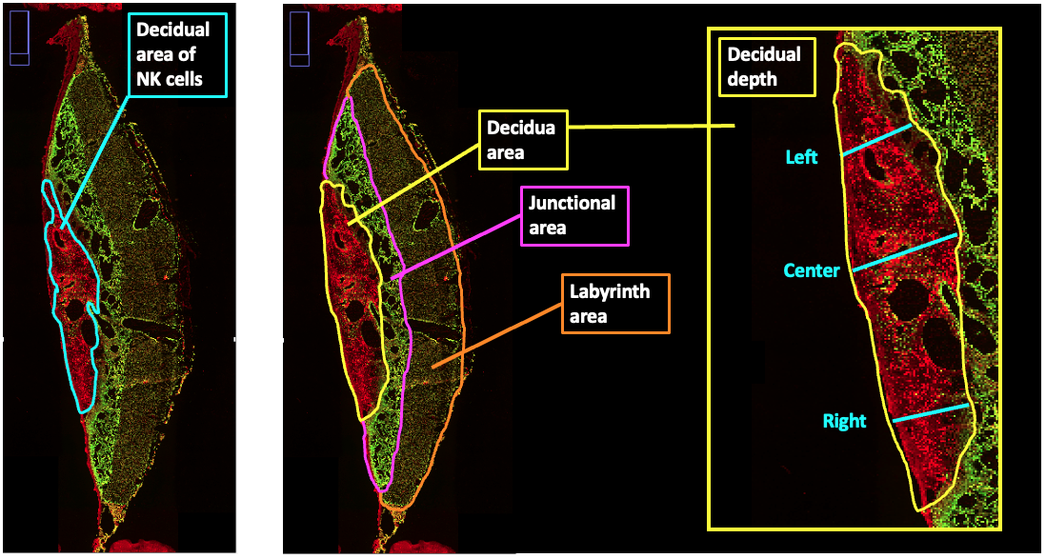

**Fiji Cheat Sheet:**

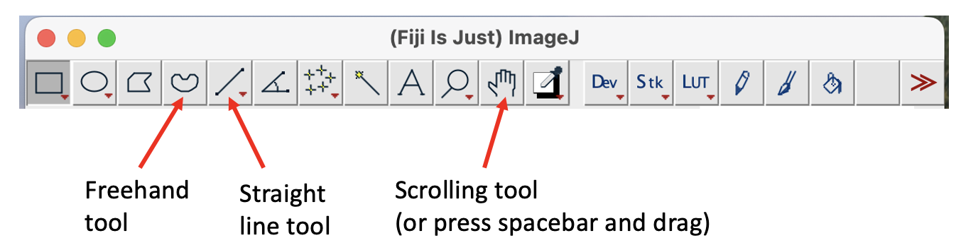

Shortcuts:

Command (⌘) A to delete line or shape

Command (⌘) m to measure

Command (⌘) + to zoom in

Command (⌘) - to zoom out

Spacebar and drag to scroll move around image

Windows:

Each merged image will have 3 channels:

* + Dapi in the blue channel (all nuclei)
  + GFP in the green channel (trophoblasts)
  + mCherry in the red channel (NK cells)

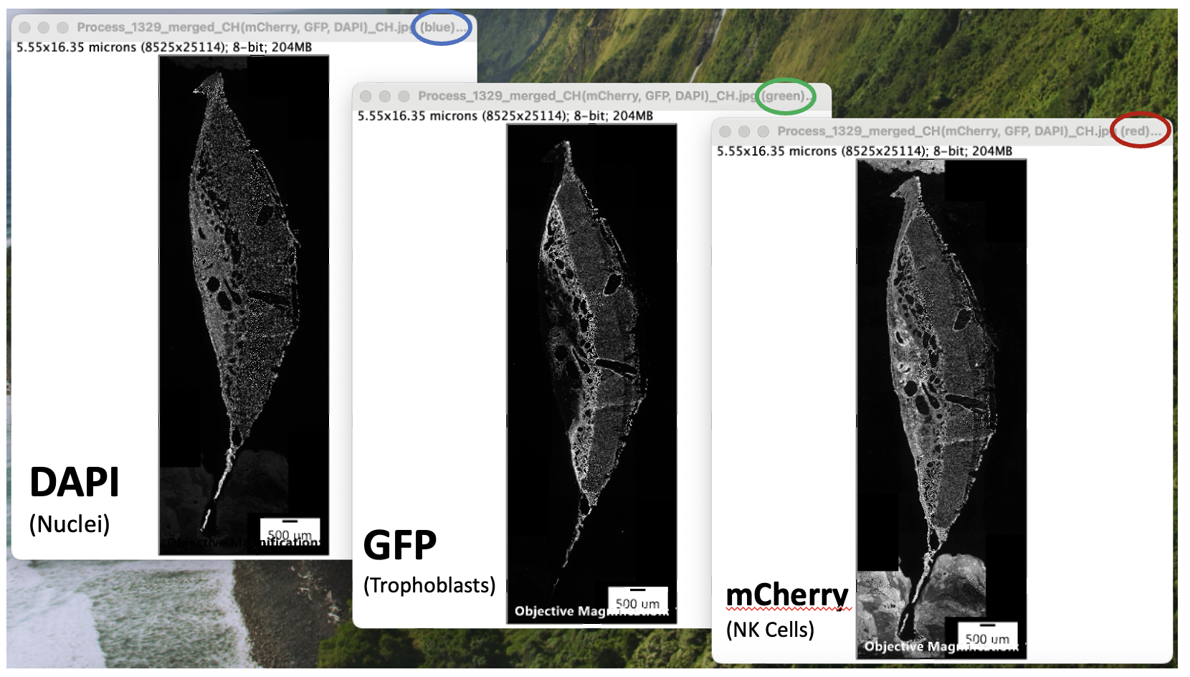

If placental measurements are too big, change the scale.

* Analyze>>set scale>>distance in pixels: 1535. Known distance: 1. Pixel aspect ratio: 1. Unit of length: microns

**Macros:**

NK_macro:

showMessage("Select image for analysis ");

open();

run("Split Channels")

//

waitForUser("Choose mCherry (red) window for threshold");

run("Duplicate...", "title=mCherry");

//run("Threshold...");

setAutoThreshold("Otsu dark no-reset");

setThreshold(240, 255, "raw");

run("Create Mask");

rename("mCherry_mask");

run("Watershed");

run("Erode");

run("Dilate")

// Prompt the user to draw a freehand selection

setTool("freehand");

waitForUser("Draw a freehand selection around NK cell mass (mCherry_mask).");

// Analyze Particles within the active selection

run("Analyze Particles...", "size=50-15000 show=Outlines display summarize add")

Tropho macro:

showMessage("Select image for analysis ");

open();

run("Split Channels")

//

waitForUser("Choose GFP (green) window for threshold");

run("Duplicate...", "title=GFP");

//run("Threshold...");

setAutoThreshold("Otsu dark no-reset");

setThreshold(179, 255, "raw");

run("Create Mask");

rename("GFP_mask");

run("Watershed");

run("Erode");

run("Dilate")

// Analyze Particles within the active selection

setTool("freehand");

waitForUser("Draw a freehand selection around placenta (GFP_mask).");

// Analyze Particles within the active selection

run("Analyze Particles...", "size=50-15000 show=Outlines display summarize add")

Color macro:

showMessage("Select image for analysis ");

open();

run("Split Channels")

//

waitForUser("Choose dapi (blue) window");

run("Blue");

rename("Dapi");

waitForUser("Choose mCherry (red) window");

run("Red");

rename("mCherry");

waitForUser("Choose GFP (green) window");

run("Green")

rename("GFP")

//

run("Merge Channels...", "c1=mCherry c2=GFP c3=Dapi create");

run("Channels Tool...");

waitForUser("Select Channel 1 and Channel 2");

waitForUser("Close 'Channels Window'; Check for NKs in placental zones and conduct placental measurements");

run("Set Scale...", "distance=1536 known=1 unit=micron global")